THEORY OF COMPUTATION LAB
Name: N DIMPLE BLOSSOM
Reg No: 192411227

1. DFA – Strings that start with a and end with a
Program:
#include <stdio.h>

int main() {
char s[100];
int i, valid = 1;

printf("Enter a string: ");
scanf("%99s", s);

for (i = 0; s[i] != '\0'; i++) {
if (s[i] != 'a' && s[i] != 'b') {
valid = 0;
break;
}
}

if (valid && s[0] == 'a' &&
s[i - 1] == 'a')
printf("Accepted");
else
printf("Rejected");

return 0;
}
Output:
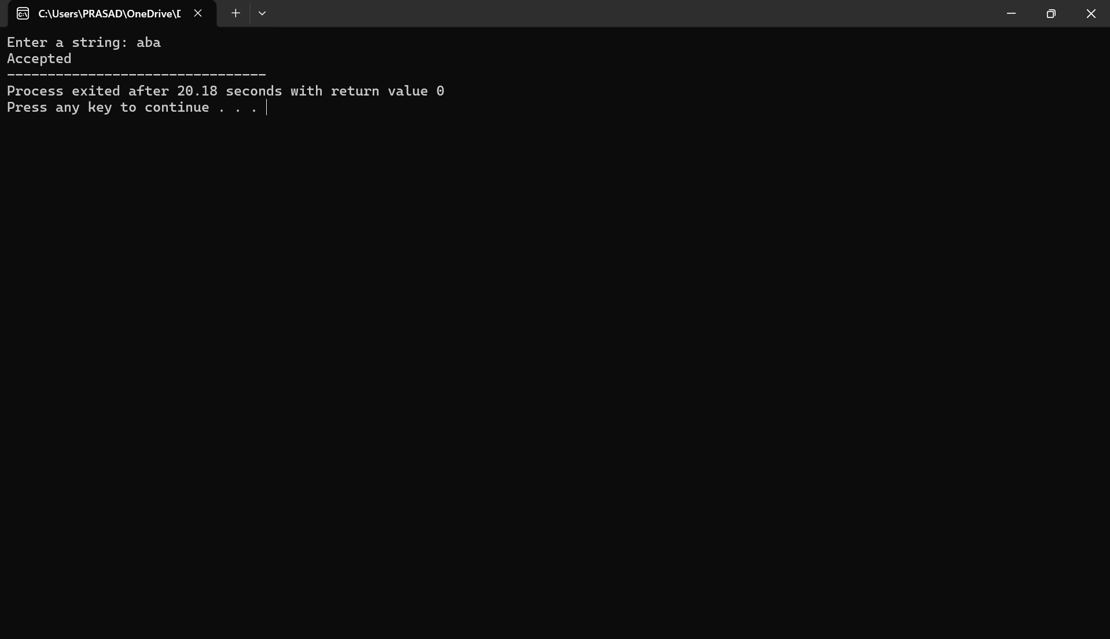

2. DFA – Strings that start with 0 and end with 1
Program:
#include <stdio.h>
int main() {
char s[100];
int i, valid = 1;

printf("Enter a string: ");
scanf("%99s", s);

for (i = 0; s[i] != '\0'; i++) {
if (s[i] != '0' && s[i] != '1') {
valid = 0;
break;
}
}

if (valid && s[0] == '0' &&
s[i - 1] == '1')
printf("Accepted");
else
printf("Rejected");

return 0;
}
Output:
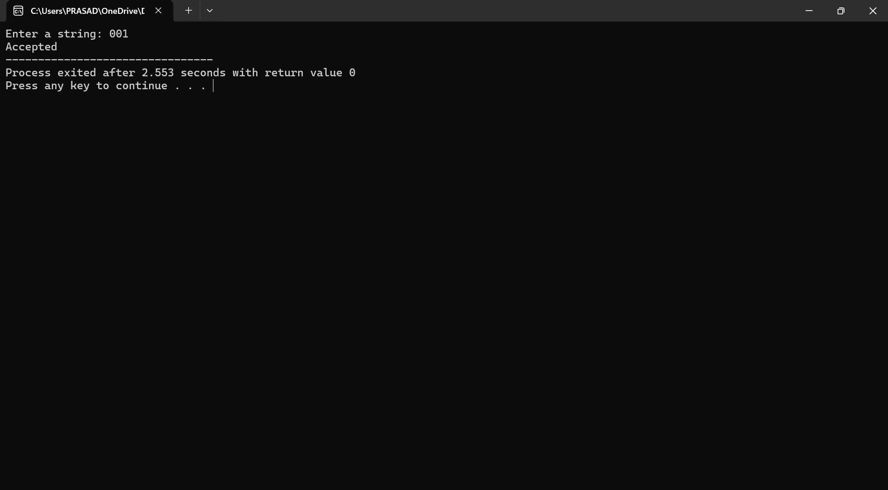

3. CFG – Check whether a string belongs to the grammar
Program:
#include <stdio.h>
#include <string.h>

int main() {
char s[100];
int i, valid = 1;
int len;

printf("Enter a string: ");
scanf("%99s", s);

len = strlen(s);

if (len < 2 || s[0] != '0' ||
s[len - 1] != '1')
valid = 0;

for (i = 0; i < len; i++) {
if (s[i] != '0' && s[i] != '1') {
valid = 0;
break;
}
}

if (valid)
printf("String belongs to CFG");
else
printf("String does not belong to CFG");

return 0;
}
Output:
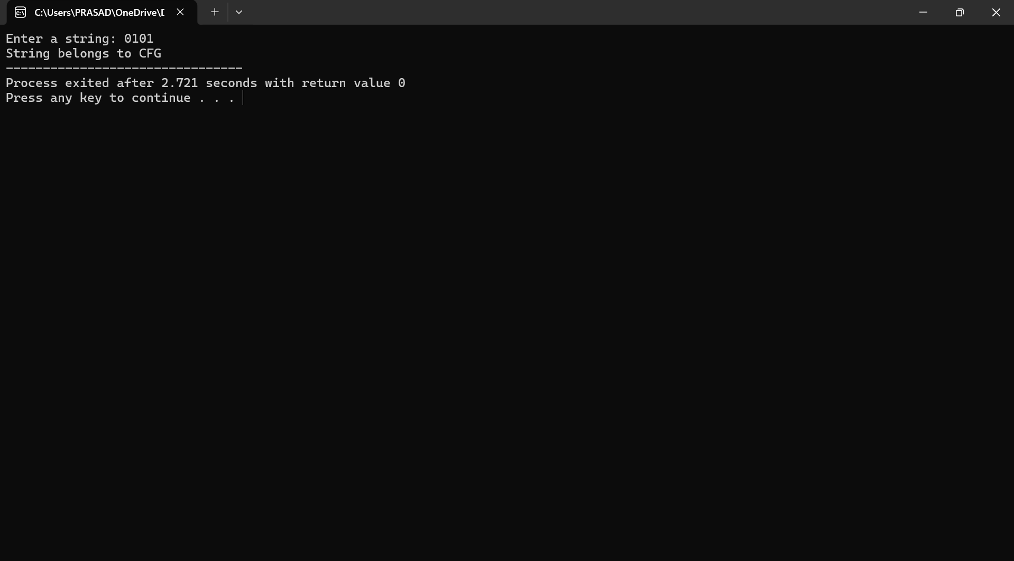

4. C Program to Check CFG Membership
Program:
#include <stdio.h>
#include <string.h>

int main() {
char s[100];
int i, len, flag = 1;

printf("Enter a string: ");
scanf("%99s", s);

len = strlen(s);

for (i = 0; i < len / 2; i++) {
if (s[i] != s[len - i - 1]) {
flag = 0;
break;
}
}

if (flag)
printf("String belongs to CFG");
else
printf("String does not belong to CFG");

return 0;
}
Output:

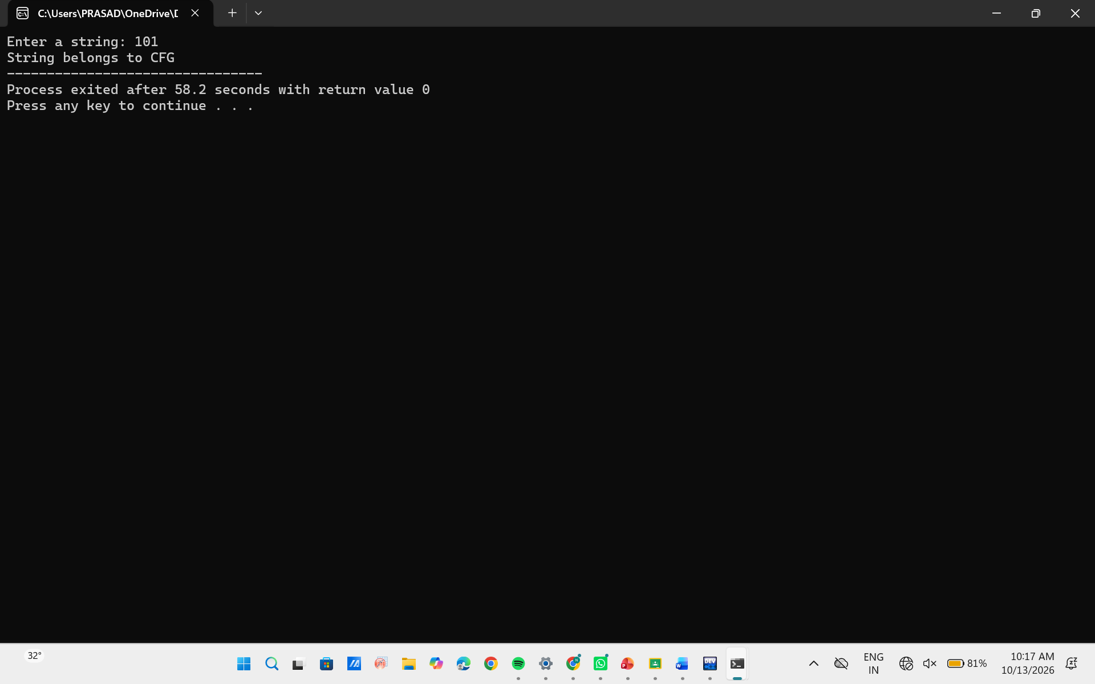

5. C Program – CFG Membership
Program:
#include <stdio.h>
#include <string.h>

int main() {
char s[100];
int i = 0, j, valid = 1;

printf("Enter a string: ");
scanf("%99s", s);

while (s[i] == '0')
i++;

j = i;

while (s[j] == '1')
j++;

while (s[j] == '0')
j++;

if (s[j] != '\0')
valid = 0;

if (valid && j == strlen(s))
printf("String belongs to CFG");
else
printf("String does not belong to CFG");

return 0;
}
Output:
